**Guidance Class Lesson for the week of April 27-May 1**

**Let’s learn about careers and community helpers!**



Hello Amazing 2nd graders and families! I miss you all so much!

This week we are learning about careers and jobs! One day you will grow up and have a job of your own. It’s never too early to be dreaming dreams and setting goals for your future! Everything you do in school each year is preparing you for your future job and career. So if you haven’t started thinking about what you want to do when you grow up, start dreaming now!

**Also, we want to think about the people who have been working hard during this time we are at home. You will have the opportunity to thank someone who has been helping others during this difficult time.

Lesson 3: Careers

1.Read the book, “When I Grow Up” by Andrew Daddo and Jonathan Bentley

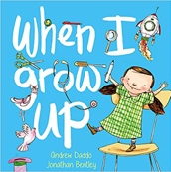

<https://youtu.be/OE3OPA-VFM0>

2. Watch the video, “Kids Respond to First Responders.”

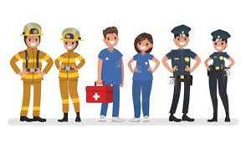

<https://youtu.be/xniHKJol2Ao>

3. Choose one or more of these activities to do at home.

* Poster: Print [here](../CareerDay3.pdf) or from my webpage. Please email it to me and I can share it on the webpage!
* Thank-you note to a first responder. Print here or from my webpage.

**More fun resources:**

Listen to the short song called, “Career Day” by the Bazillions.

<https://www.youtube.com/watch?v=CR71AhdHadM>

Here is another video by the Storybots, “What to be when you grow up.”

<https://youtu.be/ufGCxcU0iWE>